travel route planning

2022.09.19

Preamble

Preamble 2

Introduction 5

Aim and Objectives 6

Background material 6

Problem 7

Application of the chosen approach 8

Recommendation and conclusion 22

Critical Evaluation 42

Conclusion 51

Reflection/Learning 52

References 53

**Summary**:

As a very popular leisure activity, travel is loved by many people all over the world. Usually, tourists have different preferences for their itinerary, limited time budget, and are not familiar with the wide range of points of interest (POI) in the city, so planning itineraries is very tedious, time-consuming and challenging. them. In this article, we propose an algorithm that integrates traditional path planning combined with external factors to be used for travelers' personalized itinerary planning to better plan their itineraries. First, we consider the expected starting POI (for example, the POI near their hotel) and the destination POI (for example, the POI near a train station or airport) in our method.

The goal of our entire project is to plan the route planning and design of tourist attractions by considering the path planning itself and external factors: social network analysis, social network discussion heat, weather and other external variables.

利用社交平台feeds用户自发上传的旅游评价数据、热度信息、天气情况等路线数据挖掘出有用的旅游信息，在传统的路线规划方法上增加了景点讨论热度、对景点服务的好坏程度的度量，可实现一天内更细颗粒度（按小时进行路线规划），不仅拓展了数据的应用范围，也满足了用户体验式旅游的需求。

通过预计算的方法搜索旅游路线。基于图论的思想将景点数据映射为有向带权图，用图的各个结点代表景点，图中有向边代表两景点之间的通行路线。有向边的权值代表访问两个景点所消耗的时间，包括景点游玩时间和景点与景点之间的通行时间。再结合访问景点的热度、群众毫无程度的平均度量、天气情况和两景点之间的关联程度，采用基于dj算法遍策略来搜索满足时间约束的所有通行路线。

运用回归模型对旅游路线进行评分、排序，目的是为了在运算时能更快地识别路线输出的先后顺序。利用旅游路线数据作为测试数据集，以单纯的简单最短路线、对比赋予社交网络热度、社交网络评价喜好程度根据经验赋予先天权重进行测试，对比简单的路线和复杂路线规划。同时对于同一组时间点、一组景点的外部因素（景点在社交网络喜好平均值、天气情况）的影响和热度关系的关联性预测，这部分主要使用啦ARIMA模型，衡量社交网络和外部数据引入，对于最终预测热度的影响程度。

（新增主题介绍：**Use the travel evaluation data, heat information, weather conditions and other route data uploaded by users of the social platform feeds to mine useful travel information, and increase the popularity of scenic spots discussion and the measure of the quality of scenic spots services on the traditional route planning method. It can achieve finer granularity in one day (route planning by hour), which not only expands the application scope of data, but also meets the needs of user experience tourism.**

**Search travel routes by precomputed methods. Based on the idea of ​​graph theory, the scenic spot data is mapped into a directed weighted graph, and each node of the graph is used to represent the scenic spot, and the directed edge in the graph represents the passage between the two scenic spots. The weights of the directed edges represent the time spent visiting two attractions, including the time spent playing the attractions and the travel time between attractions. Combined with the popularity of visiting scenic spots, the average measure of the crowd, weather conditions and the degree of correlation between the two scenic spots, the dj algorithm-based traversal strategy is used to search for all the travel routes that meet the time constraints.**

**The regression model is used to score and sort tourist routes, in order to identify the sequence of route output more quickly during operation. Using the travel route data as the test data set, the test is carried out with the simple shortest route, the social network popularity by comparison, and the social network evaluation preference given innate weights based on experience, and the simple route and complex route planning are compared. At the same time, for the same set of time points and external factors of a set of scenic spots (the average value of scenic spots in social network preferences, weather conditions) and the correlation prediction of the heat relationship, this part mainly uses the ARIMA model to measure the introduction of social networks and external data. , the degree of influence on the final predicted popularity**）

**Keywords**:

Personalized tour Itinerary planning Popularity data Geospatial network

Pathfinding algorithm Social network analysis Thermal analysis Variable fitting

开源数据采集；深度学习；数据挖掘

Open-source Data Collection; Deep Learning; Data Mining

Introduction

With the advent of post-modern society, the new generation pays more attention to personalized services.

In travel planning, a perfect plan that fits the individual can save a lot of time and energy.

When most people make travel plans, they make travel city route planning based on friend recommendations, word of mouth, travel company advertisements, etc., without the help of data analysis, and without taking into account the popularity of the Internet, the public opinion analysis of the social network, and the weather. Planning factors.

In order to achieve these goals, a series of scenic spots with weights are provided to each tourist for each city. Furthermore, comprehensive consideration of factors such as distance, weight, travel time and attraction characteristics, recommends an optimal travel sequence for tourists, so that they can take the least distance to visit the most desired scenic spot within the travel time limit.

Before starting to travel, tourists can make and select some scenic spots that the city generally wants to visit according to their own hobbies. Then we use big data to monitor twitter/quora/google trend/weather forecast sites and other data, analyze the popularity of each scenic spot, the general mood of the public and the general public on social networks, combine these factors, and then consider the traditional Path finding algorithm, comprehensively carry out different route planning. Give people more choices

Aim and Objectives

In order to solve the problem that scenic spots are worth visiting, we need to know the judging of whether scenic spots are good or bad. I ask the wisdom of the people for help. The algorithm also used this method to estimate the popularity of social networks (you can estimate the flow of people), and to find people's emotional tendencies. Here, we use the same technique to understand the general tour sequence, so that it will feel good to be compiled into our user's itinerary. We combine the knowledge of popular times of attractions with the directions between these attractions, and maybe in the future, we can figure out what tourists like to do when they travel.

Background material

Another algorithm to solve the problem of spatio-temporal tourism planning is to obtain a sequence of tourist attractions by cyclically executing the following operations. First, select the n largest weighted scenic spots that are connected to the current scenic spot and have not been visited; secondly, calculate and compare the value of these scenic spots, and select the most valuable scenic spot; then, update the total tour time and add it The tour of this attraction is time-consuming and the distance between this attraction and the previous attraction is time-consuming. If the total tour time is less than, the scenic spot will be added to the sequence; otherwise, the scenic spot will be ignored and the total tour time value will be restored. say

When tourists pay more attention to the characteristics of scenic spots, the algorithm is effective. However, this method may result in a long travel distance and time consuming between attractions.

3 easy-to-think algorithms

**Starting point distance method** (Spiral)

With the starting point as the center of the circle, find the sequence of points that are getting farther and farther from the starting point, connecting these points from the starting point to the farthest, and finally connecting to the ending point. The time complexity is O(n).

**Current nearest method** (Nearest)

Starting from the starting point, find the nearest point of the current point in turn (except for the points that have been passed), and the sequence formed is connected from the starting point to the end point in turn. The time complexity is O(n).

**Exhaustion best method** (Exhaustion)

Exhaust the complete arrangement of all points except the starting point and the end point, and calculate the total length of each possible route, take the minimum value and return the optimal value plan. The time complexity is O(n!).

Problem

When most people make travel plans, they make travel city route planning based on friend recommendations, word of mouth, travel company advertisements, etc., without the help of data analysis, and without taking into account the popularity of the Internet, the public opinion analysis of the social network, and the weather. Planning factors.

Application of the chosen approach

**1.1 Twitter key account network analysis**

**1.1.1 why we do network analysis**

They extract data from social media, blogs, wikis, and other user-generated content to provide new ideas and methods for travel route planning. This public data can be combined with other data from such as location data and social network networks, and processed using artificial intelligence (deep learning sentiment analysis model) to provide updates on what’s happening in the city, as well as a series of help to develop Descriptive and predictive analysis of the itinerary and development of travel routes.

At a macro level, this can help determine travel route demand and behavior trends, enabling them to make more informed responses and planning. For example, if the system detects an increase in negative sentiment information from a certain area of ​​the city, it may be that artificial intelligence can classify and text photos with relevant geographic tags to find the problem-it may be that the street is in disrepair, or Someone deliberately vandalized-we should choose to avoid attractions that are too negative.

On the contrary, the increase in social media positive reviews and the heated discussion of newly renovated parks can be used as a measure of the success of the project. Because of social media, natural language processing, and sentiment analysis, they can now understand public opinions and behaviors in real time.

We mainly use networkx to draw the relationship diagram, meanwhile we use Matplotlib and numpy are used for data analysis and preprocessing. They use the python built-in library for data cleaning and simple pipe connection and processing. The data download is obtained through twitter api and my own crawler program.

For hot locations, we can first conduct data exploration and social network analysis on twitter to confirm that this is a normal transmission path, rather than some targeted social network advertising (some areas or scenic spots will do this) )

**1.1.2 methodology of twitter key account network analysis**

**networkx**

**图像**

As an open source package of Python, NetworkX is convenient for users to create, operate and learn complex networks. Using networkx, you can store networks in standardized and non-standardized data formats, generate a variety of random networks and classic networks, analyze network structures, establish network models, design new network algorithms, and perform network drawing, etc. In NetworkX, there are the following 4 basic graph types:

Graph: Refers to the undirected graph, that is, the direction of the edge between two nodes is ignored.

DiGraph: Refers to a directed graph (directed Graph), which considers the directionality of the edges.

MultiGraph: Refers to multiple undirected graphs, that is, the number of edges between two nodes is more than one, and the vertex is allowed to be related to itself through the same edge.

MultiDiGraph: a directed version of the multigraph

All graph classes allow hashable objects as nodes. Hashable objects include strings, tuples, integers, etc. Any edge attributes (such as weights and labels) can be associated with edges.

The internal data structure of the graph is based on the adjacency list representation, and the dictionary data structure is implemented using python. The graph adjacency structure is implemented as a python dictionary; the external dictionary is keyed by nodes to values, these values themselves are dictionaries, and the adjacent nodes are keyed to the edge attributes associated with the edge. This "dict of dicts" structure allows quick addition, deletion and search of nodes and neighbors in large graphs. Directly access the underlying data structure through the methods in the class definition (programming interface "api"). On the other hand, all functions only use these API methods instead of directly acting on data structures to manipulate graphics-like objects. This design allows replacing the dicts-based "dicts of dicts" data structure with alternative data structures that implement the same method.

**Numpy**

NumPy is the basic package of scientific computing in Python. It is a Python library that provides multi-dimensional array objects, various derived objects (such as masked arrays and matrices), and various APIs for fast array operations, including mathematics, logic, shape operations, sorting, selection, input and output , Discrete Fourier Transform, basic linear algebra, basic statistical operations and random simulation, etc.

The core of the NumPy package is the ndarray object. It encapsulates python's native n-dimensional array of the same data type. In order to ensure its excellent performance, many operations are executed after the code is compiled locally.

There are several important differences between NumPy arrays and native Python Arrays (arrays):

NumPy arrays have a fixed size when created, which is different from Python's native array objects (which can grow dynamically). Changing the size of the ndarray will create a new array and delete the original array.

The elements in the NumPy array all need to have the same data type and therefore have the same size in memory. Exception: When Python's native array contains NumPy objects, in this case arrays with elements of different sizes are allowed.

NumPy arrays facilitate advanced math and other types of operations on large amounts of data. Generally, these operations are performed more efficiently and less code than using Python's native arrays.

More and more Python-based science and mathematics packages use NumPy arrays; although these tools usually support Python's native arrays as parameters, they will still convert the input arrays to NumPy arrays before processing, and also Usually the output is a NumPy array. In other words, in order to efficiently use today's science/mathematics Python-based tools (most of the scientific computing tools), it is not enough that you only know how to use Python's native array types-you also need to know how to use NumPy arrays.

**Python and Matplotlib**

​ Nowadays, the two most commonly used programming languages for data analysis are R and Python. Among them, R, as an old data analysis language, integrates a large number of commonly used tools in mathematical statistics and economics, and is an indispensable programming language for data analysis. In recent years, with its powerful ecology, Python has many open source data processing modules, such as Numpy, Pandas, scipy, Matplotlib, SKlearn, etc., which have become the dark horse of data analysis programming languages.

​ Speaking of using Python for data visualization, the most important module is Matplotlib. At the beginning, it was a drawing module developed in a way that imitated Matplotlib. After iteration, it can be maturely compatible with Numpy and Pandas, which is convenient and fast to use. On the other hand, more advanced modules like Seaborn are also developed on the basis of Matplotlib. Although it is more efficient, if you want to control every control of the picture more flexibly, you still need to master Matplotlib.

Matplotlib is a python-based plotting library that fully supports two-dimensional images and limited support for three-dimensional graphics. Matplotlib is a visual operation interface library of the python programming language and its data science extension package NumPy. It uses the adopted graphical user interface toolkit (such as Tkinter, wxPython, Qt, FLTK, Cocoatoolkits or GTK+) to provide an application programming interface (API) to the application embedded drawing. In addition, Matolotlib also has a pylab interface based on image processing libraries (such as graphics library OpenGL), and its design is very similar to MATLAB. SciPy is to use Matplotlib to draw graphics

采用 B/S 模式开发基于小时间段旅游路线规划平台，通过引入Web服务器完成终端与数据服务器的无缝衔接，采用Flask/vue/bootstrap/cros api的终端开发技术，后台 数据库管理采用稳定高效的sqlsite3实现。通过用户交互的体验方式实现输入、输 出的过程，结合开源地图API将运行结果在地图上展现，直观地告诉用户有哪些 符合其需求的路线可以选择，并展示每条路线的游览顺序。

（**The B/S model is used to develop a travel route planning platform based on a small time period. The seamless connection between the terminal and the data server is completed by introducing a web server. The terminal development technology of Flask/vue/bootstrap/cros api is adopted. The background database management adopts stable and efficient sqlsite3 implementation. The process of input and output is realized through the user interaction experience. Combined with the open source map API, the operation results are displayed on the map, which intuitively tells users which routes that meet their needs can be selected, and displays the tour sequence of each route.**）

**2.0 Findings**

**social network analysis**

First let use see London Eye eye tweets ’s week/month/month social network analysis

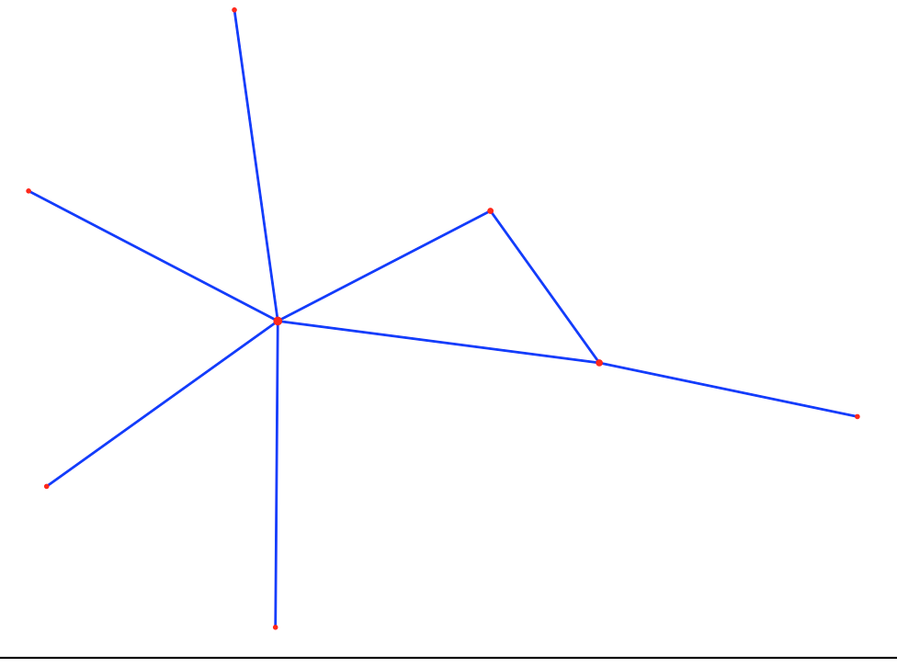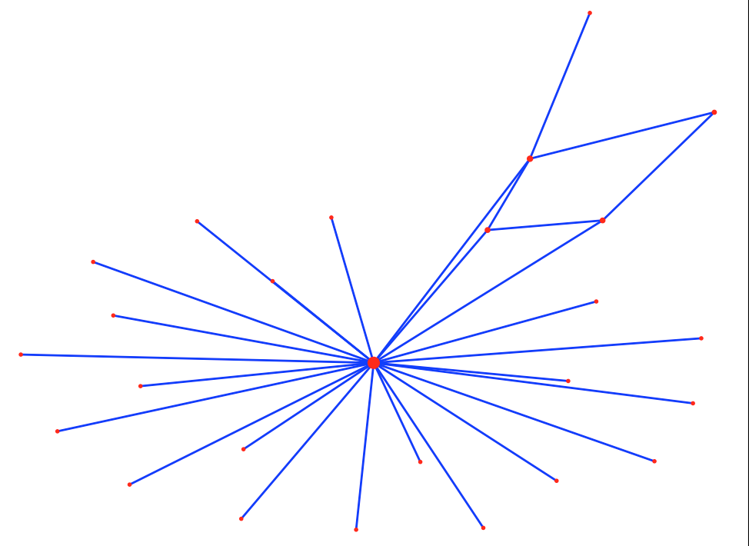

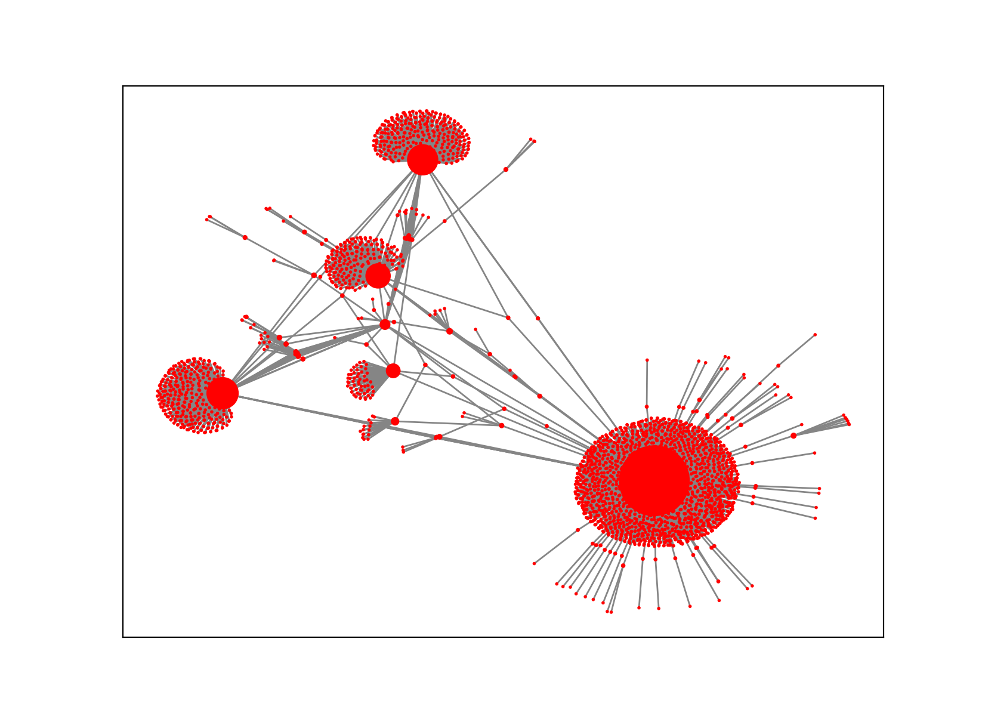

Then let use see Leadenhall Market ’s week/month/month social network analysis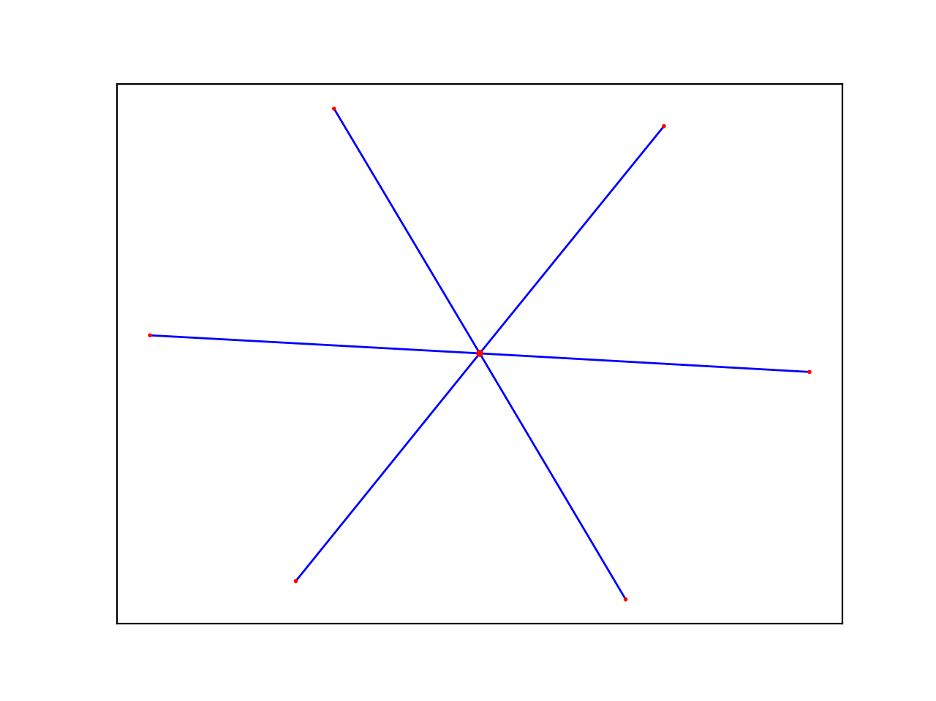

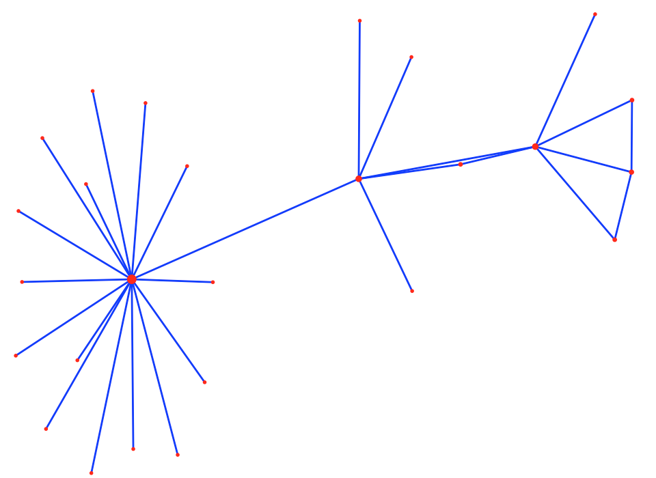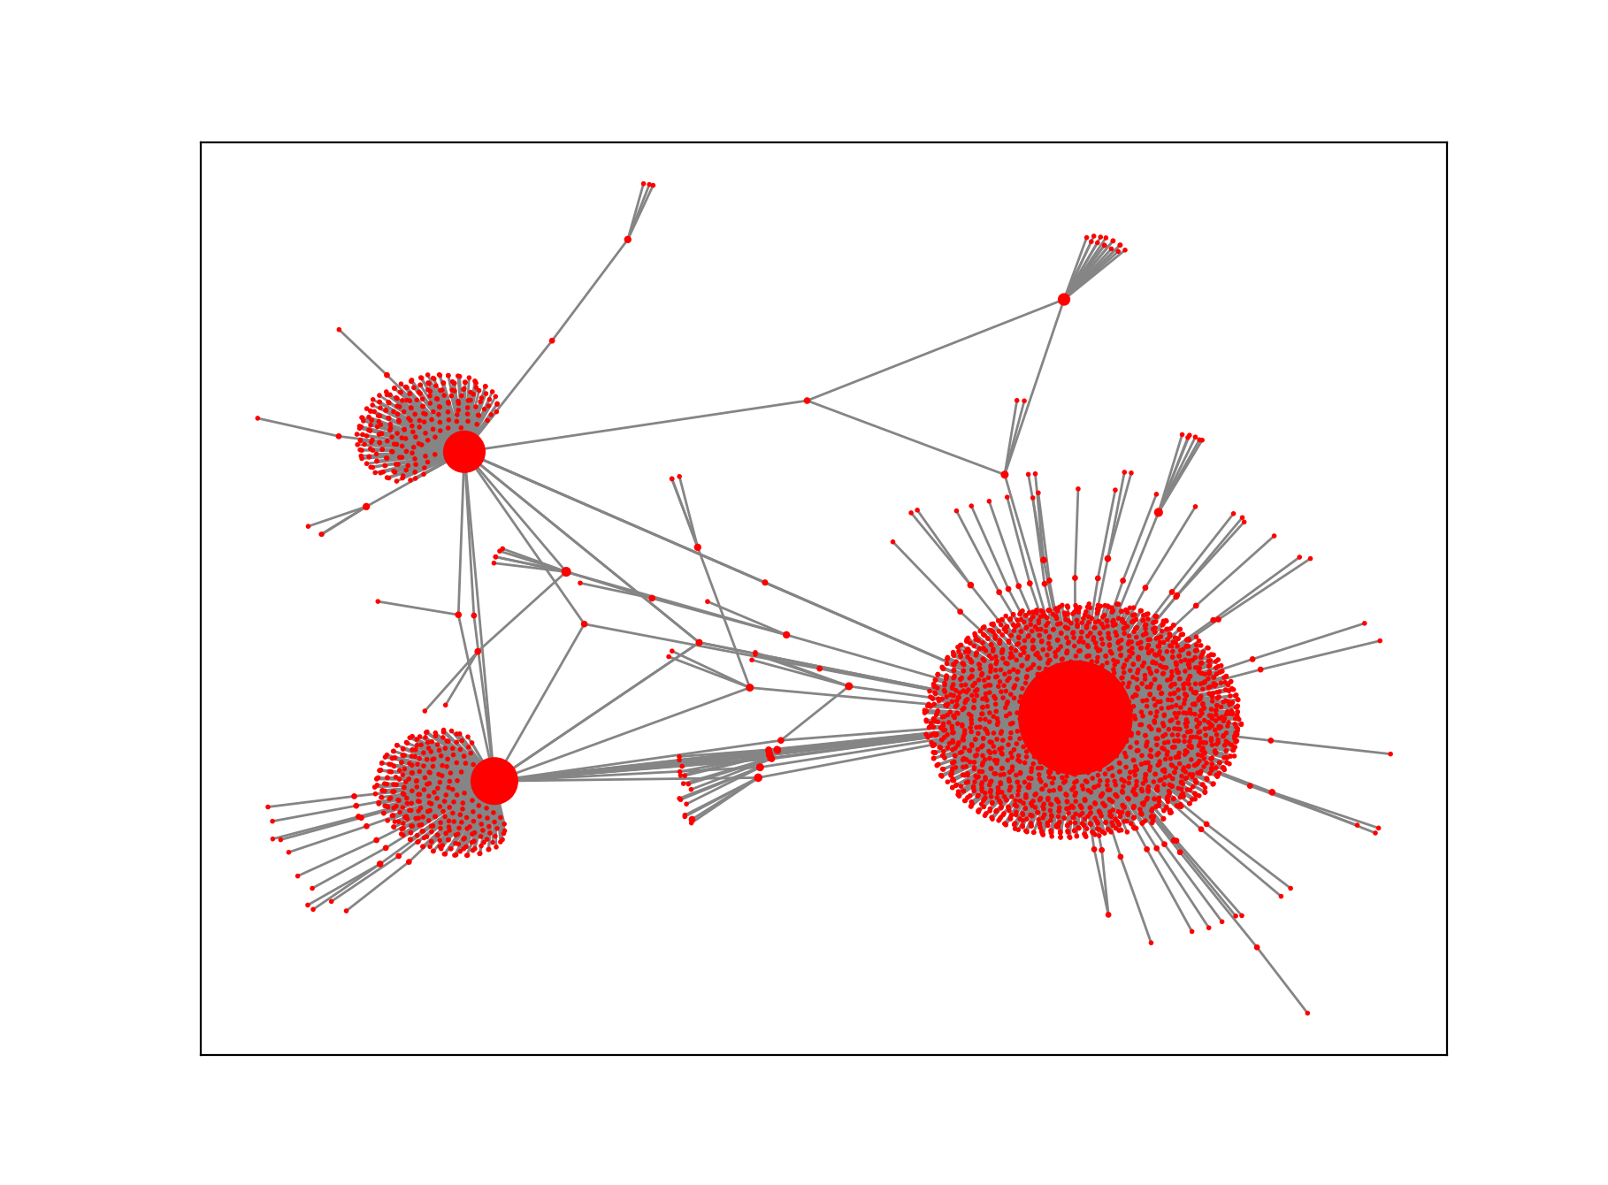

With the advent of the era of big data, people's awareness of accumulating data has become stronger and stronger, so how to obtain the information we want from the accumulated data has attracted more and more attention. Public comments on social networks, twitter or facebook, company e-mail records, disease development, website visits, etc. More and more data that can be connected to the network is saved, so learning to analyze these data can help us find the information we need in the messy connection relationship

We first use networkX to grab the data of Twitter to obtain the key data of 2 on Twitter. The results show that the network density is 0.0904, indicating that the actors in the network have a certain degree of relevance. There are a total of all nodes in the network. There are 3287 lines, the longest distance between nodes is 6, and that is, the longest distance between any two nodes is 6 lines. The distance reflects the length of the interval between actors, and the smaller the distance, it means that each other the closer the connection. In other words, on Twitter, the media organizations can be connected to each other through up to 5 nodes, which is less than the average distance between any two people in the world that is only 5 nodes apart from the "six degrees of separation" theory emphasizes. In addition, the average distance between the network nodes is 2.937, which means that any two media agencies only need to pass through the intermediary of 1 to 2 nodes to become the interconnected nodes in the network.

The London Eye’s network ’s more then 8000 edges, meanwhile the Leadenhall Market ’s network’s 5000 edges. The dataset we uses is about year of 2020 till now.

If we regard Social Network Analysis as an application as a research method, sometimes it can also be used as a research perspective (perspective). Of course, some middle-level theories have also been produced. The more common ones are Granovetter's weak connection theory, Burt's structural hole theory, Watts' small world model, and Barabasi's Power Law.

The previous social sciences often focused on the characteristics of individuals (or actors, such as companies, individuals), and ignored the relationships between individuals. The study of social networks is precisely the method and perspective of studying relationships. The biggest feature is that it considers the interdependence between individuals, which is closer to the real society. Displaying these relationships with the pictures shown in the title, you can intuitively see the position of each actor in the network and the overall structure of the network. Looks very dazzling and very advanced.

A network can be defined from the following three aspects:

**sentiment analysis on MVP of #Place twitter account**

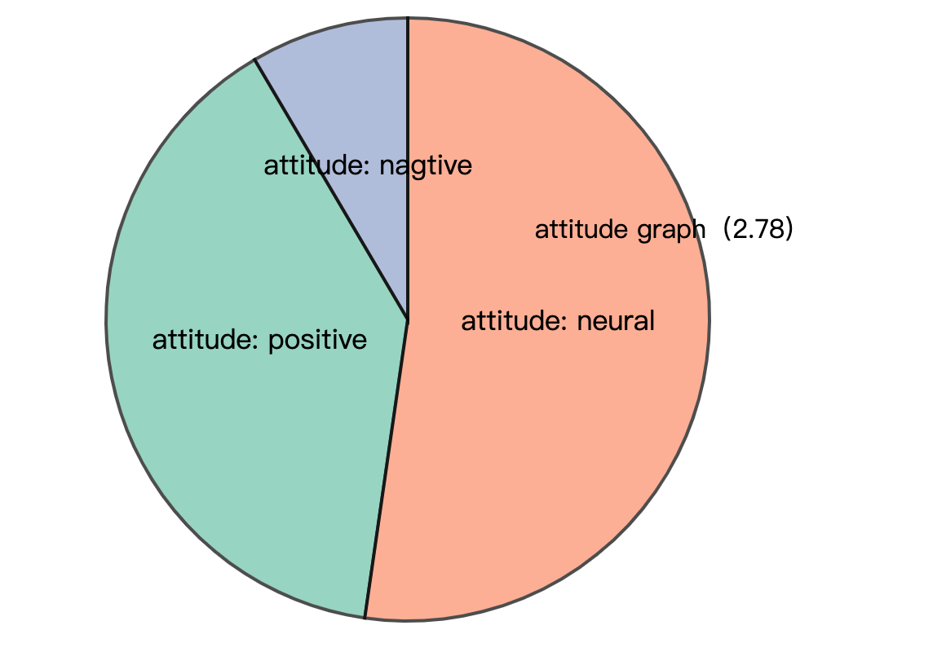

Figure 1 below is the sentiment analysis statistics of London Eye's sent tweets and reposts, and Figure 2 is the sentiment analysis statistics of paul's sent tweets and reposts

Figure 1

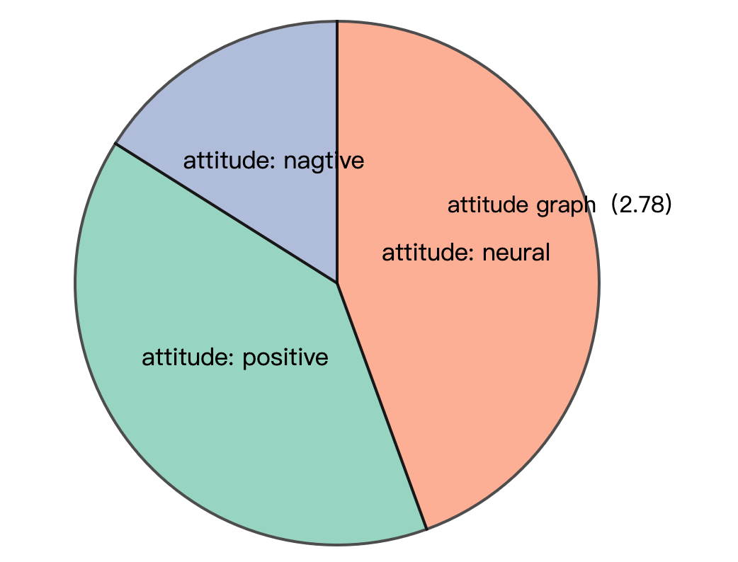

Figure 2

The explosive development of social network services such as Twitter has also brought great opportunities for researchers. Researchers can analyze the public's emotional changes by analyzing a large amount of emotional data, and have an impact on government management, economics, and entertainment. From the perspective of the government and managers, the United Nations has developed an application for global emotional fluctuation monitoring, Global Pulse, and Beihang’s research team launched the first online emotional system for Chinese Weibo, MoodLens; Romney and Obama during the 2012 US general election Intense propaganda was launched on Twitter to influence ordinary people and journalists, becoming a typical case of Internet participation in the presidential election. In terms of financial applications, many research institutions apply sentiment analysis technology to stock analysis and forecasting systems. For example, Stock Sonar displays daily positive and negative sentiment information for the stock next to the hotness of each stock, providing investors with instant information For reference, the Twitter sentiment analysis developed by UIC is used to predict and track the rise and fall of the stock market. In the entertainment field, Alibaba Cloud’s artificial intelligence system "Little Ai" successfully predicted Coco Lee's victory in the "I Am a Singer" program. It also relied on live data and comment data on social networks to analyze and predict. Text sentiment analysis technology. It can be seen that the monitoring, analysis and prediction of social media's emotional big data continue to influence government decision-making and public choice.

The time when the text is published can usually be obtained using simple rules. Therefore, the goal of sentiment analysis is usually to automatically analyze the three elements of Holder, Target, and Polarity from unstructured text. . Holder is the issuer of the opinion; Target is the object of the opinion evaluation (such as the entity or entity's attributes, or topic); Polarity is the emotion type expressed. Due to different tasks, the emotion category system will be different, usually including praise and criticism. , Joy, anger, sorrow, joy, sorrow, and emotional scoring (such as 1-5 points) classification system The emotions in the text are divided into explicit emotions and implicit emotions. Explicit emotions refer to emotional texts that contain obvious emotional words (such as happy and beautiful), and implicit emotions refer to emotional texts that do not contain emotional words, such as "this There is a layer of ash on the table." Since implicit sentiment analysis is more difficult and relies on background knowledge and common sense knowledge, many current works focus on the research of revealed sentiment analysis. In this report ,we are just use revealed sentiment analysis of (Polarity)

We do it at the sentence level, it determines whether its sentiment is positive, negative or neutral for each sentence of the document. Unlike the previous document level, some descriptive sentences actually have no emotion, so there is a neutral category here, which means there is no emotion. This question has something to do with subjectivity classification-subjectivity classification is to judge whether a sentence is subjective or objective. Usually neutral sentences are objective, while positive or negative sentiment sentences are subjective. But they are not exactly the same. For example, "We bought the car last month and the windshield wiper has fallen off" is an objective sentence, but it describes an undesirable thing, so it implies negative emotions. Although the sentence "I think he went home after lunch" is subjective, it has no positive or negative emotions

We can see :

London Eye have or retweet more postive tweets than Leadenhall Market, but in common, the are on the Internet, most topics (more than 1/2) are neutral.

**Google search analysis**

The “Audiences" report in Google Analytics can view the details of visitors. This information can help you tailor content to attract audiences. If you use paid advertising, you can use this report to optimize your targeting .First we anlysis their reteet rules from the time and frequence. Then we count the most send / reteet topic . We then search topics on google trends to find the Most relevant.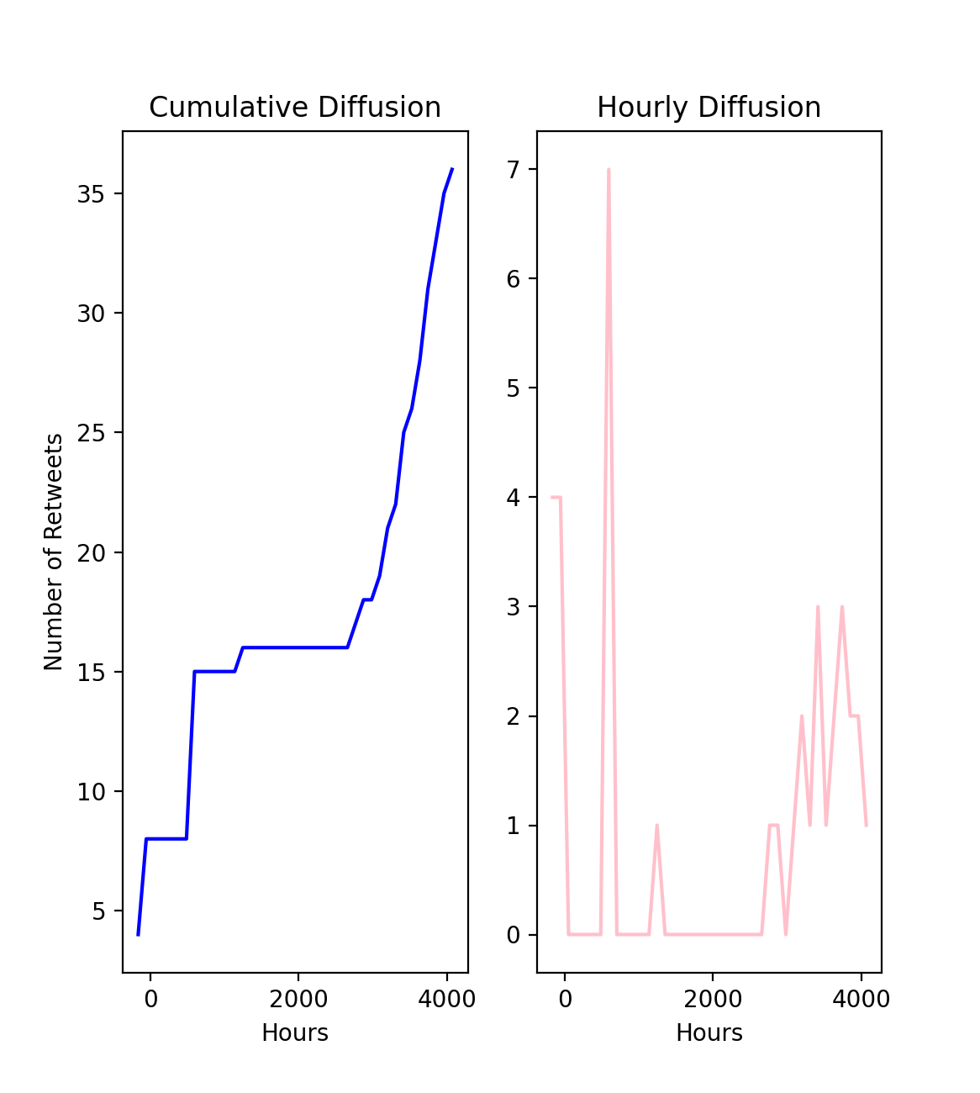

London Eye frequencly of send

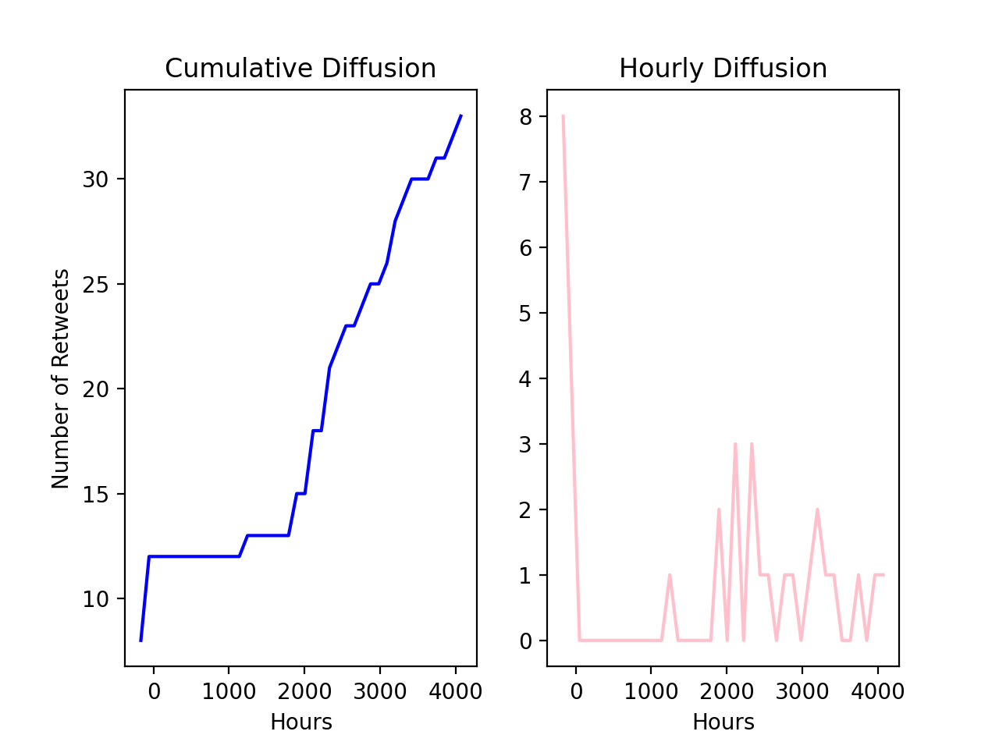

paul frequencly of send

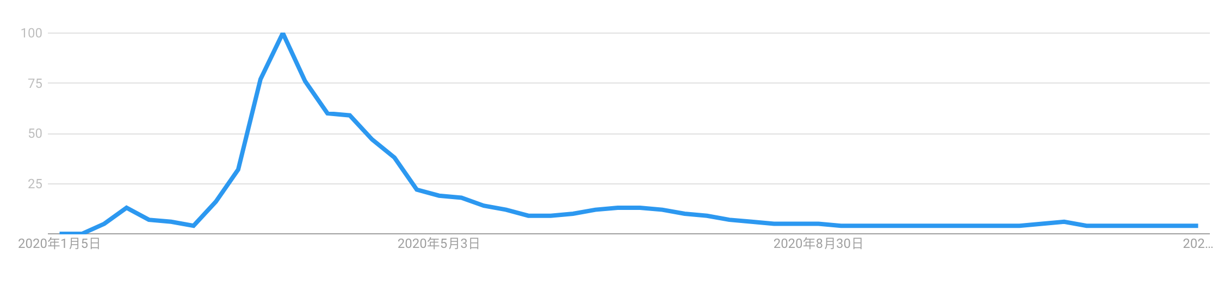

London Eye’s tweet interaction rules are more random, but there are no loosening rules for a few months in the middle, and the popularity is not affected; and Paul uses tweets to interact with the audience with similar probability throughout the year.

Through the Google search correlation analysis, it can be seen that the main audience of London Eye is most concerned about the bitcoin hotness and blockchain-related news.

Pual’s audience is most relevant to some news and discussions about the new crown

Recommendation and conclusion

The 21st century is a century in which mankind is highly dependent on data and deeply integrated into the information society. In the information society, online social networks have built a huge functional platform. People express opinions and make friends and interact on social networks, and hundreds of millions of information are generated every day. Online social interaction is changing people's behavior patterns and social patterns. Online social network data is also becoming the most mature big data. Through research and Analyzing this technology, people are expected to have an unprecedented depth of understanding of user behavior and social phenomena behind online social network big data.

This analysis is very enlightening

Common place:

1. Stay hot and interact with your audience frequently. Of course, the most important thing is to be sincere and discuss the issues that you really care about (for London Eye is the future of mankind, journey to Mars, testla, reduce global warming), for Paul, he is most concerned about how to help the initial entrepreneurship People, build alliances for them, news about the new crown pneumonia and how to help everyone tide over the difficulties
2. Both individuals have maintained close communication with their most important partners. It can be seen from the visualization of social networks that there are basically 3 and 4 communication objects and groups, and not all topics and groups are involved. It is important to choose your own groups and interest groups
3. Be objective, sincere, and enthusiastic. Through sentiment analysis, it can be found that the two people still maintain a neutral attitude on most topics, and post meaningful opinions and reposts mainly in areas that they are familiar with.

**1.2 sentiment Model for all #Place tweets**

**Native Bayes model and compare**

**Naive Bayes is a probabilistic classifier, which means that for document d, among all categories [formula], the classifier returns the category [formula] with the greatest posterior probability of a given document.**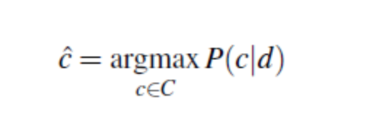

**In Naive Bayes, we will discover how each word affects emotion, which can be calculated by the ratio of the probability of occurrence of two types of words. Let us take an example. We can see that the word "negative" is more likely to appear in the negative category than in the positive category. Therefore, we will find the ratio of these probabilities for each word through the formula:**

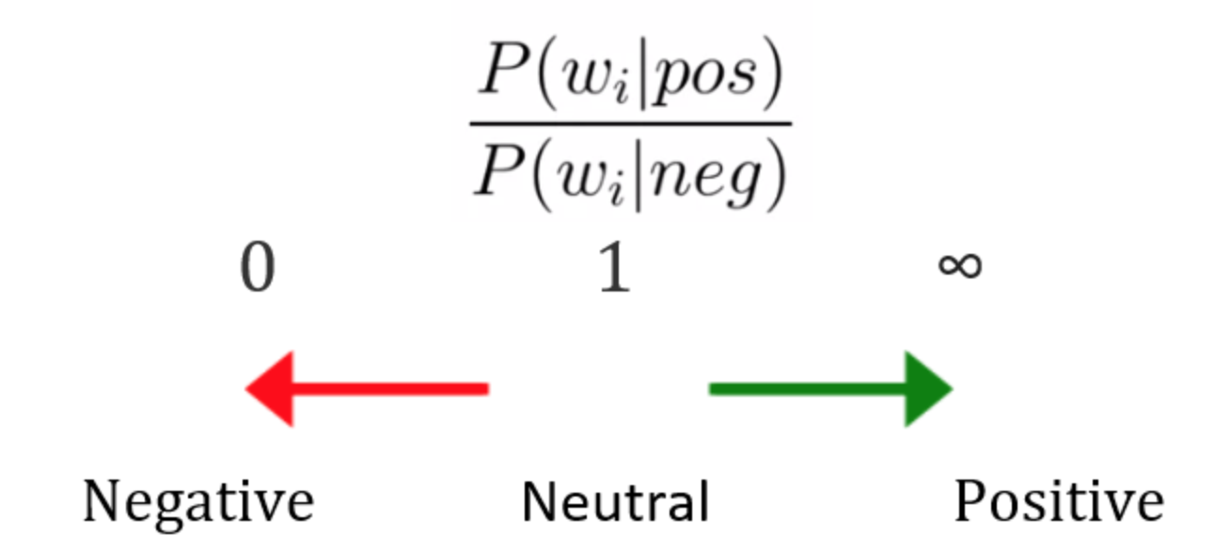

**Before we started train dataset , first we should do data pre-processing to remove useless tags:**

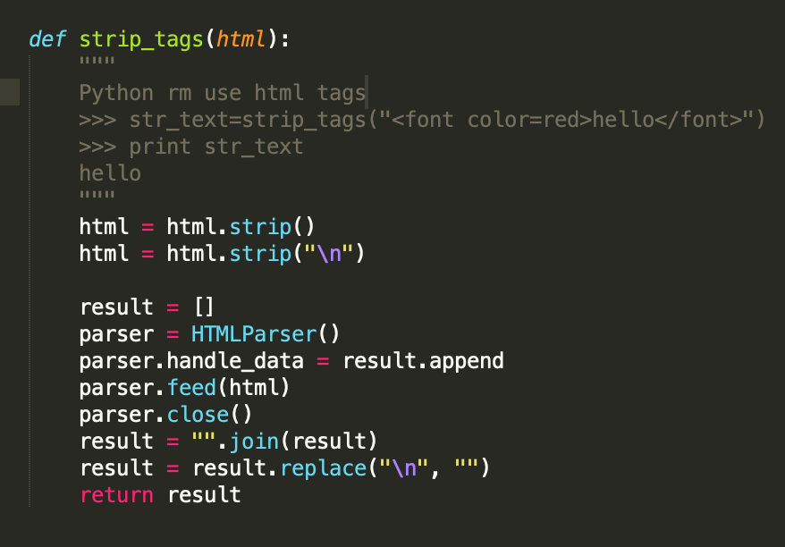

**Then we need to choose stop words used in Native-bayes model:**

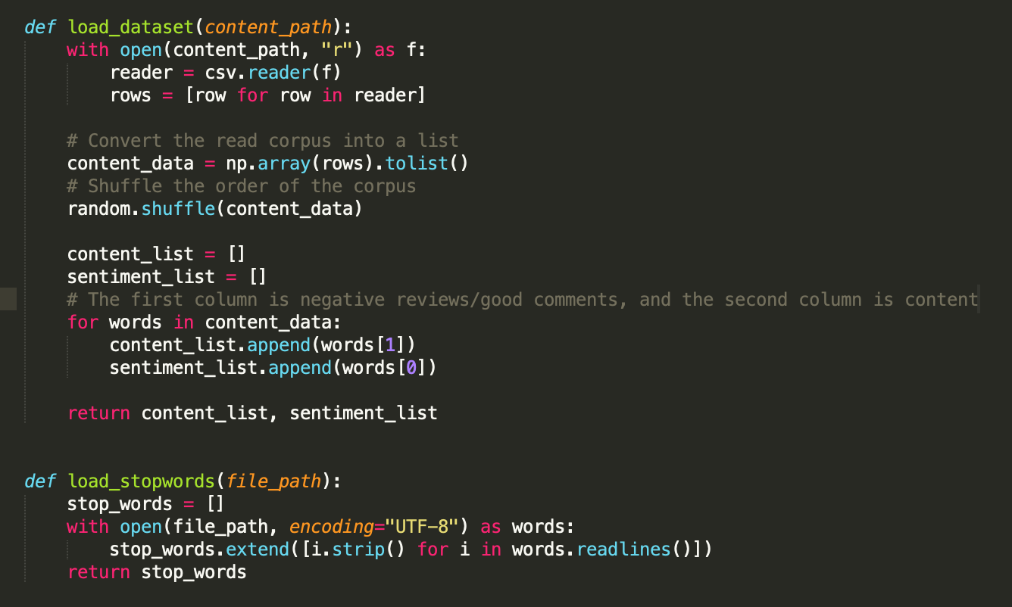

**Then we make proper pipe line to load our model and split dataset to train/test to exmine and run many epochs:**

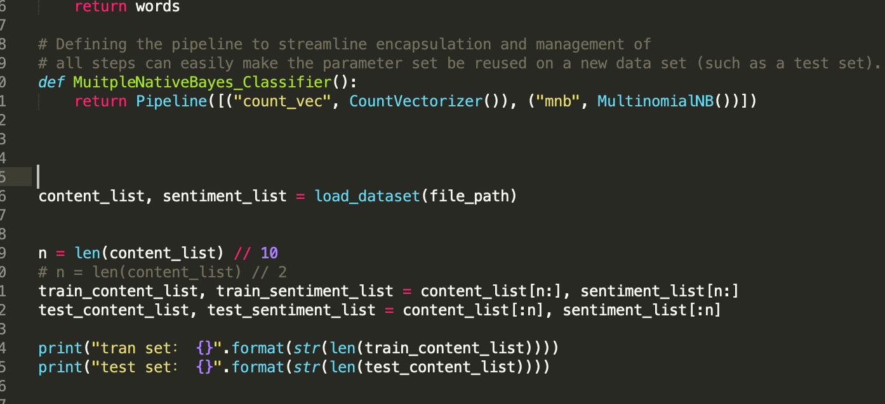

**Our ultimate goal is to deploy the trained model to the real environment. We hope that the trained model can get a good prediction effect on real data. In other words, we hope that the model predicts less error on real data. We get our model run on the test dataset , the best is 0.78, which is still lower than our deep learning model ,wchi accuracy is 0.7978, and even faster than Native Bayes model. We will introduce the Deep learning model in later.**

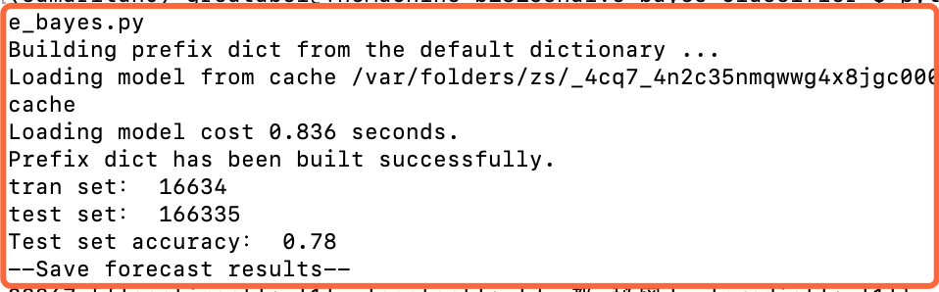

**1.2.1 What model we choose and why**

Sentiment analysis or opinion mining is a computational study of people's opinions, emotions, emotions, evaluations and attitudes about products, services, organizations, individuals, issues, events, topics and their attributes. The beginning and rapid development of this field is consistent with the development of social media, such as comments, forums, blogs, Weibo, Twitter and social networks, because this is the first time in human history that there are such a large number of digitally recorded views data. As early as 2000, sentiment analysis became one of the most active research fields in NLP. It has been extensively studied in data mining, web mining, text mining and information retrieval. In fact, because of its overall importance to business and society, it has expanded from computer science to management and sociology, such as marketing, finance, political science, communication, health science, and even history. The reason for this development is that viewpoints are at the core of almost all human activities and are important factors influencing human behavior. Our beliefs, our perception of reality, and the decisions we make depend to a large extent on the way others see and evaluate the world. Therefore, when we make decisions, we usually seek the opinions of others. Not just individuals, but also organizations.

Existing research has produced a large number of techniques that can be used for multiple tasks in sentiment analysis, including supervised and unsupervised methods. Among the supervised methods, early papers used all supervised machine learning methods (such as support vector machines, maximum entropy, naive Bayes, etc.) and feature combinations. Unsupervised methods include different methods using sentiment dictionaries, grammatical analysis, and syntactic patterns. There are many review books and papers, covering the early methods and applications extensively.

About ten years ago, deep learning became a powerful machine learning technology, which produced the current best results in many application fields, including computer vision, speech recognition, NLP, etc. The application of deep learning to sentiment analysis has also become popular recently. This article first summarizes deep learning, and then reviews sentiment analysis based on deep learning.

In this report comprehensively describes deep learning to achieve sentence-level sentiment analysis (positive, neutral, optimistic), mainly introduces the department we hope to use deep learning to predict sentiment, try to surpass the sentiment analysis performance of traditional machine learning algorithms, and analyze the problem in detail. The functions that need to be completed, and the system development process, development tools and techniques used are explained. After completing the model training, the machine learning model is engineered and turned into an AI web service, which can be used by the website. From the four angles of system requirement analysis, outline design, detailed design, and realization of functional modules, the development process of the system is explained in detail, and the main characteristics of the system are introduced.

**1.2.2 Development Tech Stack we choose**

Introduction of development technology and tools

a. tensorflow development framework

TensorFlow is an end-to-end open source machine learning platform. Provide comprehensive and flexible professional tools to enable individual developers to easily create machine learning applications, help researchers to promote the development of cutting-edge technology, and support enterprises to establish stable large-scale applications.

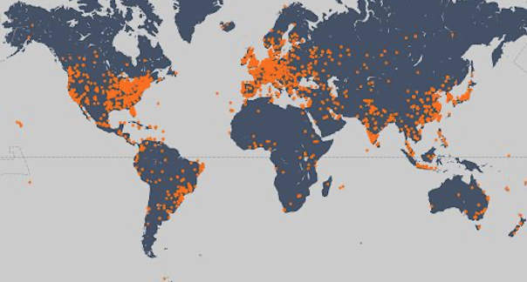

Since its release in 2015, TensorFlow has had 41 million downloads worldwide. As a widely used machine learning framework around the world, TensorFlow has passed its third anniversary, and TensorFlow has gradually become an end-to-end mature platform with a complete ecosystem. With the release of TensorFlow 2.0, it marks the arrival of a new era of TensorFlow, which is easier to use, more flexible and powerful, and more usable in production environments. I hope TensorFlow can become a machine learning platform suitable for all users and can help everyone use it. Machine learning solves real-world problems.

Machine learning is mainly divided into two steps: training and deployment.

In the training phase, TensorFlow not only supports Python, but also provides support for Swift and JS languages. You can choose the language you are familiar with for development.

In the deployment phase, TensorFlow models can run on different platforms, support TensorFlow Serving deployed on the server side, TensorFlow Lite deployed on end-side platforms such as Android, iOS and embedded devices, and TensorFlow.js deployed on browsers and Node servers. And many languages ​​including C language, Java language, Go language, C# language, Rust and R

B. keras

Keras is a neural network library written in pure Python, focusing on deep learning, running on TensorFlow or Theano.

TensorFlow and Theano are currently two popular deep learning libraries, but they are relatively complicated for beginners.

Keras is simple to use and has a clear structure. The underlying computing platform can be based on TensorFlow or Theano with powerful functions.

Keras can run in Python 2.7 or 1.5 environment, perfectly combined with GPU and CPU, released under the MIT license.

Keras is developed and maintained by Google engineer François Chollet.

The following are the design principles of Keras:

o Modularity: A model can be understood as an independent sequence or graph. The models are independent of each other and can be freely combined.

o Minimalism: Each module should be as concise as possible. Each piece of code should appear intuitive and easy to understand when it is first read. There is no black magic, because it will cause trouble for iteration and innovation.

o Extensibility: Adding a new module is super simple and easy. You only need to imitate the existing module to write a new class or function. The convenience of creating new modules makes Keras more suitable for advanced research work.

o Collaboration with Python: Keras does not have a separate model configuration file type (for comparison, caffe has), the model is described by Python code, making it more compact, easy to debug and easy to expand.

C. NumPy

NumPy is the basic package of scientific computing in Python. It is a Python library that provides multi-dimensional array objects, various derived objects (such as masked arrays and matrices), and various APIs for fast array operations, including mathematics, logic, shape operations, sorting, selection, input and output , Discrete Fourier Transform, basic linear algebra, basic statistical operations and random simulation, etc.

The core of the NumPy package is the ndarray object. It encapsulates python's native n-dimensional array of the same data type. In order to ensure its excellent performance, many operations are executed after the code is compiled locally.

There are several important differences between NumPy arrays and native Python Arrays (arrays):

• NumPy arrays have a fixed size when created, which is different from Python's native array objects (which can grow dynamically). Changing the size of the ndarray will create a new array and delete the original array.

• The elements in the NumPy array all need to have the same data type, so they have the same size in memory. Exception: When Python's native array contains NumPy objects, in this case arrays with elements of different sizes are allowed.

• NumPy arrays facilitate advanced math and other types of operations on large amounts of data. Generally, these operations are performed more efficiently and less code than using Python's native arrays.

• More and more Python-based science and mathematics software packages use NumPy arrays; although these tools usually support Python's native arrays as parameters, they will still convert the input arrays to NumPy arrays before processing, and It is also usually output as a NumPy array. In other words, in order to use today's science/mathematics Python-based tools (most of the scientific computing tools) efficiently, it is not enough that you only know how to use Python's native array types-you also need to know how to use NumPy arrays.

D. Jupyter Notebook

Jupyter Notebook is a web-based application for interactive computing. It can be applied to the whole process of calculation: development, document writing, running code and displaying results.

In short, Jupyter Notebook is opened in the form of a web page, and you can write and run the code directly on the web page. The running result of the code will also be directly displayed under the code block. If you need to write a description document during the programming process, you can write it directly on the same page, which is convenient for timely description and explanation.

A web application is a tool based on a web page format that combines writing instructions, mathematical formulas, interactive calculations, and other rich media forms. In short, web applications are tools that can implement various functions

Documents are all the input and output of interactive calculations, writing instructions, mathematical formulas, pictures, and other rich media forms in Jupyter Notebook, which are all embodied in the form of documents.

These documents are saved as JSON format files with the suffix .ipynb, which is not only convenient for version control, but also convenient for sharing with others. In addition, the document can also be exported to: HTML, LaTeX, PDF and other formats

Main features of Jupyter Notebook

① It has the functions of syntax highlighting, indentation and tab completion during programming.

② You can run the code directly through the browser, and display the running result under the code block at the same time.

③ Display calculation results in rich media format. Rich media formats include: HTML, LaTeX, PNG, SVG, etc.

④ Support Markdown syntax when writing documentation or sentences for the code.

⑤ Support the use of LaTeX to write mathematical descriptions.

**1.2.3 Development Tech Stack we choose**

Experiment introduction and data reading

We hope to use deep learning to predict sentiment and try to surpass the sentiment analysis performance of traditional machine learning algorithms.

We mainly explore the following aspects:

*Use adaptive deep learning model

*Identify and deal with overfitting

*Use word embedding

* Built on a pre-trained model

We use the tweet data to read the csv and perform randomization of the data. A good practice is to shuffle the data before splitting between the training and test sets. In this way, the sentiment level is evenly distributed on the training set and the test set.

新增基于深度学习的文本处理技术

适用于文本分析的卷积神经网络

 卷积神经网络本质上来说就是几个卷积层加上非线性函数，像ReLu或者tanh。在传统的神经网络中，我们将每个输入神经元与下一层连接。这个叫做全连接层或者仿射层。在CNN中，通常用输入层上的卷积来计算输出。这就导致了局部连接，其中每个输入层的区域都是输出层的神经元连接在一起的。每层都使用了filter，通常会有成千上百的类似于上面有小框框的图那样的操作。还有一些东西叫做pooling(subsampling)层。在训练的过程中，一个CNN会基于任务自动地学习filters的值。例如，在图像分类中，一个CNN可以学会检测边，然后用边在第二层中去检测简单的形状，比如在高层中面部形状。最后一层就是一个使用这些高等特征的分类器。这里的计算有两方面值得注意：位置不变和合成(compositionality)。每个filter把局部的低维特征合成为高维特征。这就是CNN在计算机视觉任务里表现良好的原因。与图像像素不同，对于绝大多数自然语言处理的任务，输入都是矩阵形式的句子和文件。矩阵的每一行都对于这一个单词，但是也可能是一个字符。也就是，每一行都是一个表示一个单词的向量。通常来说，这些向量都是word embedding（低维表示），比如word2vec或者GloVe，但是他们也可能是one-hot向量（对应于一个词典）。在视觉中，filter经过图像的每一小块，但是在NLP中，通常使用filter滑过整个矩阵的整个行(words)。因此，filter的宽度通常是与输入矩阵的宽度相同。高度，或者说区域大小是可以变动的，但是25个单词上的滑动框在这个时候是一定的。把上面所有的都放在一起，一个NLP下的CNN如下图所示。

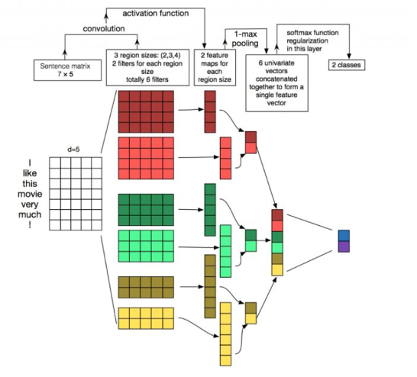

局部不变性以及局部合成是的对于图像有直观的感觉，但是对于NLP并没有这样很强的直觉。可能很关心句子中哪里会有一个单词出现。像素彼此很靠近的时候可能会有相关的语义，但是相同通常对于单词来说不是一回事。在很多语言中，部分短语可以被分割几个其他的单词。合成方面也不是那么明显。但是，单词很明显都是用同样的方式组合的，比如形容词修饰名词，单数这个，在高维表示中的意义并没有在计算机视觉中的大。给CNN最适合的任务就是分类，比如语义分析或者主题聚类. 卷积和池化算子会丢失一些局部的位置信息，从而使得句子标签变成了Part of Speech标签或者实体提取变得更加困难对于纯粹的CNN框架。

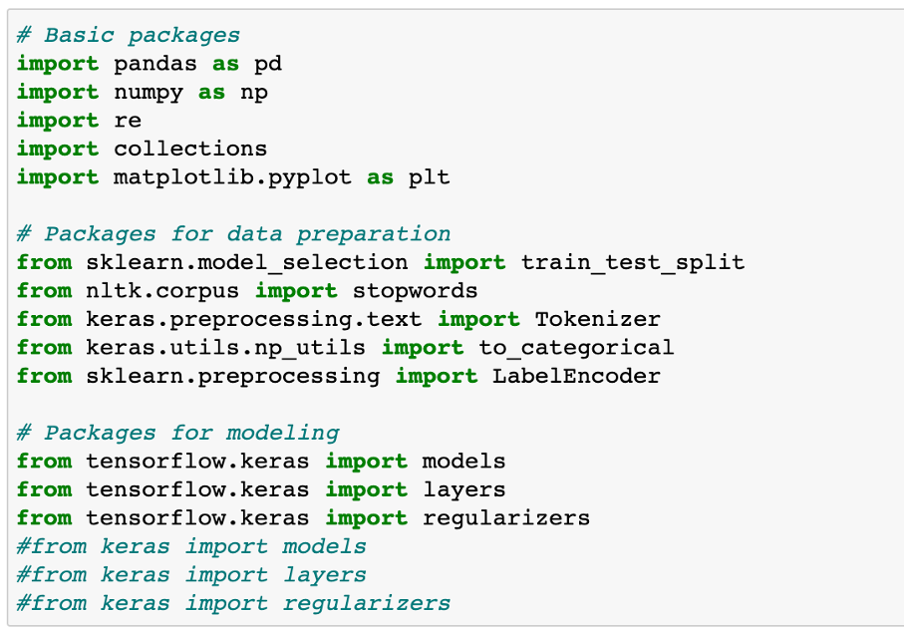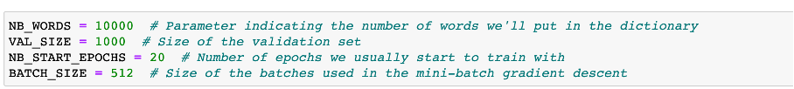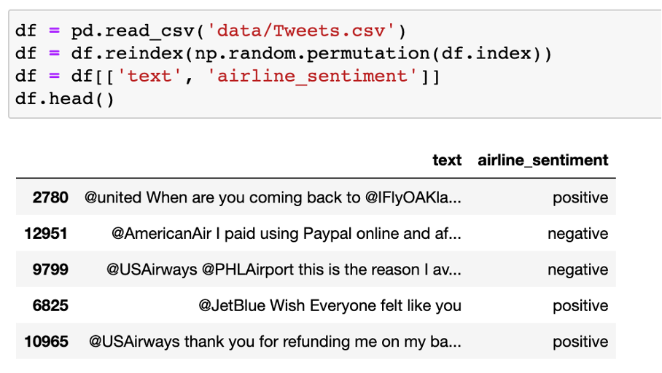

We only use the text column as input, and the airen_sentiment column as the output target.

1.2 Data preparation and data clean

Data cleaning refers to the last process of discovering and correcting identifiable errors in data files, including checking data consistency, dealing with invalid and missing values, etc. Different from the questionnaire review, the data cleaning after entry is generally done by computer rather than manually. Data cleaning-The process of re-examining and verifying data with the purpose of removing duplicate information, correcting existing errors, and providing data consistency.

Data cleaning can also tell from its name to "wash out" the "dirty", which refers to the last procedure for discovering and correcting identifiable errors in data files, including checking data consistency, dealing with invalid and missing values, and so on. Because the data in the data warehouse is a collection of data oriented to a certain subject. These data are extracted from multiple business systems and contain historical data. In this way, it is unavoidable that some data is wrong data, and some data is mutually interrelated. Conflict, these erroneous or conflicting data are obviously undesirable, called "dirty data". We have to "wash out" the "dirty data" according to certain rules. This is data cleaning. The task of data cleaning is to filter out the data that does not meet the requirements, and submit the results of the filtering to the business department to confirm whether it is filtered or amended by the business unit before extracting. The data that does not meet the requirements is mainly divided into three categories: incomplete data, wrong data, and repeated data. Data cleaning is different from questionnaire review. Data cleaning after input is generally done by computer rather than manually.

Consistency check

Consistency check is to check whether the data meets the requirements based on the reasonable value range and mutual relationship of each variable, and find out the data that is out of the normal range, logically unreasonable or contradictory. For example, if the variable measured with a scale of 1-7 has a value of 0, and the weight has a negative number, it should be regarded as out of the normal range. Computer software such as SPSS, SAS, and Excel can automatically identify each variable value out of range according to the defined value range. Logically inconsistent answers may come in many forms: For example, many respondents said that they drive to work and report that they do not have a car; or respondents report that they are heavy buyers and users of a certain brand, but at the same time they are familiar with A very low score was given on the degree scale. When inconsistencies are found, the questionnaire serial number, record serial number, variable name, error category, etc. should be listed for further verification and correction.

Handling of invalid and missing values

Due to survey, coding, and entry errors, there may be some invalid and missing values ​​in the data, which need to be dealt with appropriately. Commonly used processing methods are: estimation, whole case deletion, variable deletion and pair deletion.

Estimation. The simplest way is to replace invalid and missing values ​​with the sample mean, median, or mode of a variable. This method is simple, but does not fully consider the existing information in the data, and the error may be large. Another way is to estimate through correlation analysis or logical inferences between variables based on the answers to other questions of the respondents. For example, the ownership of a certain product may be related to household income, and the possibility of owning this product can be estimated based on the household income of the survey respondents.

Casewise deletion is to remove samples with missing values. Since many questionnaires may have missing values, the result of this approach may greatly reduce the effective sample size and make it impossible to make full use of the collected data. Therefore, it is only suitable for cases where key variables are missing, or the proportion of samples with invalid or missing values ​​is small.

Variable deletion (variable deletion). If a variable has many invalid and missing values, and the variable is not particularly important to the problem being studied, you can consider deleting the variable. This approach reduces the number of variables for analysis, but does not change the sample size.

Pairwise deletion uses a special code (usually 9, 99, 999, etc.) to represent invalid and missing values, while retaining all variables and samples in the data set. However, in specific calculations, only samples with complete answers are used. Therefore, different analyses involve different variables and their effective sample sizes will vary. This is a conservative approach that maximizes the available information in the data set.

The use of different processing methods may affect the results of the analysis, especially when the occurrence of missing values ​​is not random and the variables are clearly correlated. Therefore, in the survey, invalid and missing values ​​should be avoided as much as possible to ensure the integrity of the data

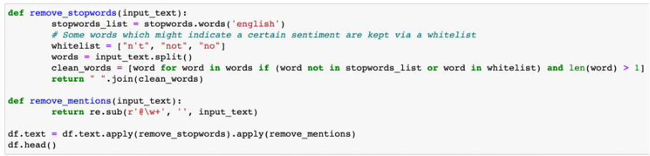

The first thing we'll do is removing stopwords. These words do not have any value for predicting the sentiment. Furthermore, as we want to build a model that can be used for other airline companies as well, we remove the mentions.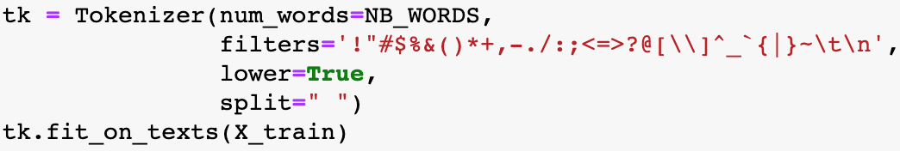

filter_out_flight_related = 'late|early|soon|minutes|phone'

df = df[df[“text"].str.contains(filter_out_flight_related)==False]

To use the text as input for a model, we first need to convert the tweet's words into tokens, which simply means converting the words to integers that refer to an index in a dictionary. Here we will only keep the most frequent words in the train set.

We clean up the text by applying filters and putting the words to lowercase. Words are separated by spaces

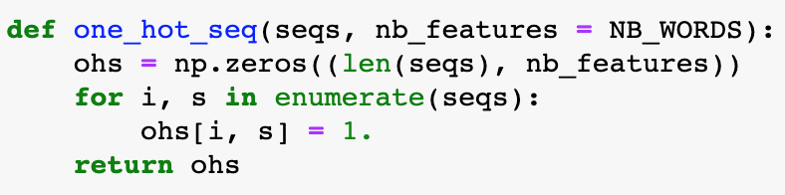



We clean up the text ，then we have done a good job of data conversion function for deep learning model training

Deep learning model

Feedforward neural network

The conventional feedforward neural network (FNN) does not consider any specific structure that the input data may have. Nevertheless, it is still a very powerful machine learning tool, especially when used with advanced regularization techniques. These regularization techniques help solve the training problems that people encounter when dealing with "deep" networks: neural networks have a large number of hidden layers, which are very difficult to train (vanishing gradients and overfitting problems). A neural network with N + 1 layers (N − 1 hidden layers). The shallow network architecture uses only one hidden layer. Deep learning requires the use of multiple hidden layers, usually containing the same number of hidden neurons. The number is approximately the average of the number of input and output variables.

FNN consists of an input layer, one (shallow network) or multiple (deep network, hence called deep learning) hidden layers, and an output layer. Each layer (except the output layer) is connected to the next layer. This connection is the key to the FNN architecture and has two main features: weighted average and activation function.

The weighted average process is to multiply the excitation value of the previous layer to the neuron and the corresponding weight matrix to obtain the input value of the next neuron. This process is shown in the figure below. We can say that the weight of the previous layer of neurons The sum is the input of the next layer of neurons.

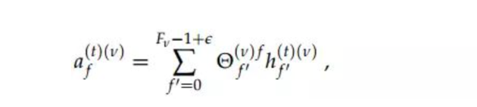

Every layer is: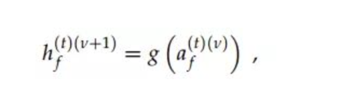

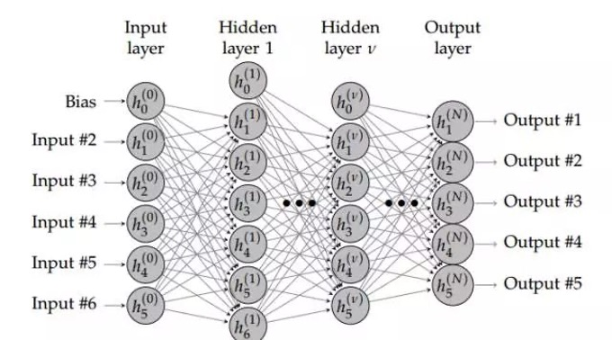

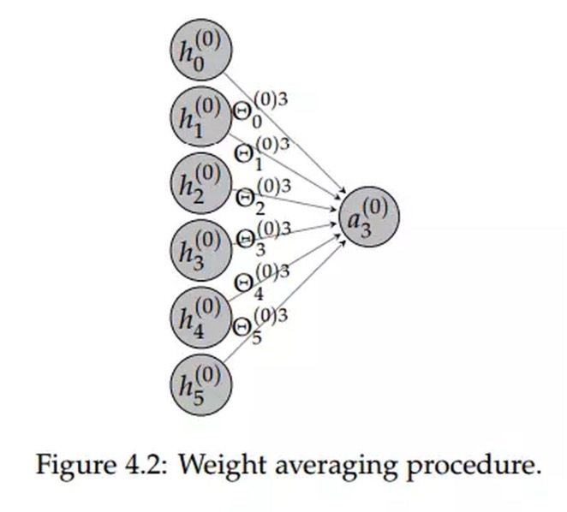

Since we need to predict 3 different emotion categories, the last layer contains 3 hidden elements. The softmax activation function ensures that the sum of the three probabilities is 1.

In the first layer, we need to estimate the 640064 weight. It depends on (nb inputs * nb hidden elements) + nb bias terms, or (10000 x 64) + 64 = 640064

In the second layer, we estimate (64 x 64) + 64 = 4160 weight

In the last layer, we estimate (64 x 3) + 3 = 195 weights

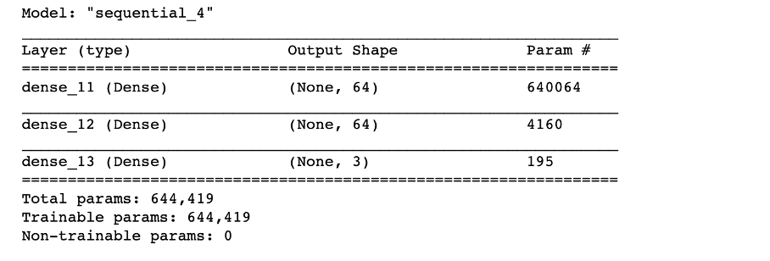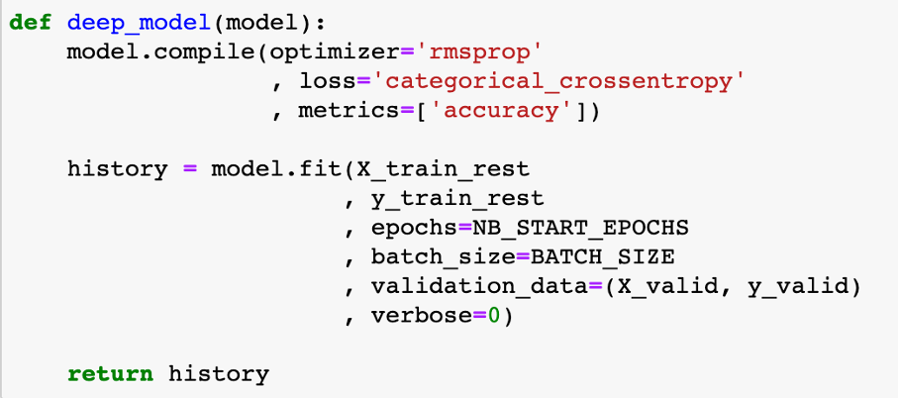

本文所使用的模型的网络架构如图4-1所示，其由4个全连接层和1个dropout层组成。全连接层是为了对输入的特征向量进行降维，dropout层是为了防止过拟合，对部分神经元随机地丢掉，以使得模型的泛化能力更强，也就是说不是仅仅去迎合训练数据的特征，而是在测试数据上也能表现出良好的泛化效果。输入层的神经元个数为10000，因为本文设置的词表大小为10000，因此在将文本进行分词处理后，每个词都转化为一个在词表中的id。词表的建立是通过训练集中每个单词出现的词频进行建立的，设置为10000是遵循了经典的自然语言处理设置模式。将每个词在词表中找到相应的id后，对id进行独热编码（one-hot），使得其可以表示离散的文本特征，然后再通过word2vec即可将离散的编码转化为连续的编码。然后输入进全连接神经网络即可进行特征提取以进一步做最终的分类。最终的分类层设置的神经元个数为3，是因为最终的标签有三类：中立、积极和消极。模型最终的输出为输入的句子向量属于这三类标签的概率。模型训练使用的损失函数为交叉熵损失函数，是用于分类问题中最为常见的损失函数。如图4-2所示，整个模型的参数量大小为320131，这些全部都是可训练的参数。

关于基线模型，本文使用全连接神经网络，第一个基线模型一共有3层，第一层的隐藏神经元个数为64，第二层的隐藏神经元个数为64，第三层的神经元个数为3，即本分类问题对应的标签个数。训练过程使用的优化器是“rmsprop”，损失函数使用的是“categorical_crossentropy”，模型的定义通过keras中的model.compile来实现。模型的训练部分使用model.fit来实现，指定好训练数据和验证数据。模型训练的周期为20，训练的batch_size大小为512。评估指标为accuracy，即分类问题的精确度。

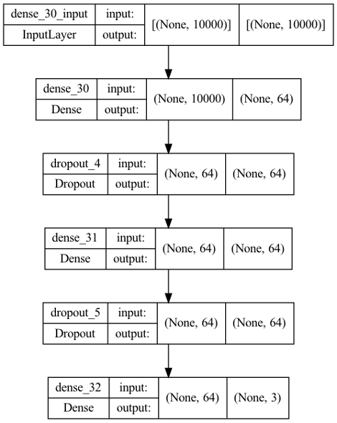

基线模型使用的是三层全连接网络，其参数量较少，在拟合上万条数据的时候容易存在过拟合的问题，因此本文对齐进行了两种优化方式：第一种是采用L2正则化的方法，第二种是采用dropout机制。二者对神经网络的优化均为防止神经网络过拟合的目标而实现。L2正则化方法的物理含义就是在代价函数后面加上一个正则化项以约束模型参数的空间范围，也是对模型的参数设定一个先验（来自于贝叶斯学派的观点）。Dropout机制本质上就是对每一层的神经元做随机丢弃，以防止模型过拟合训练数据，而在测试数据或者是验证数据上表现的效果较差。通过引入L2正则化和Dropout机制对模型全连接神经网络进行优化，可以有效地提升模型执行情感分类任务的效果

Critical Evaluation

**2.1 Training data test data set split of sentiment dataset**

The evaluation of model performance needs to be carried out in a separate test set. In this way, we can estimate the degree of generalization of the model. This is done through the train_test_split method of scikit-learn.

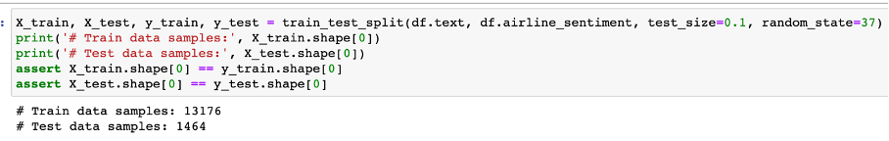

The verification loss has increased since the 4th generation. The training loss continues to decrease, which is normal because the model is trained to fit the training data as much as possible

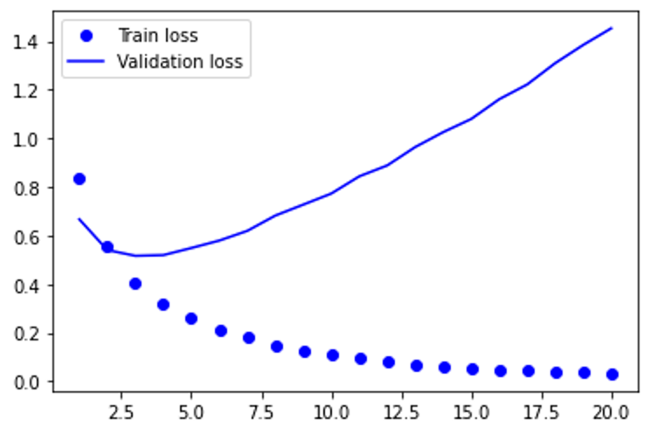

Just like verification loss, verification accuracy will peak at an earlier period. After that, it will drop slightly. To sum up, we can say that the model has been overfitting since epoch 2.

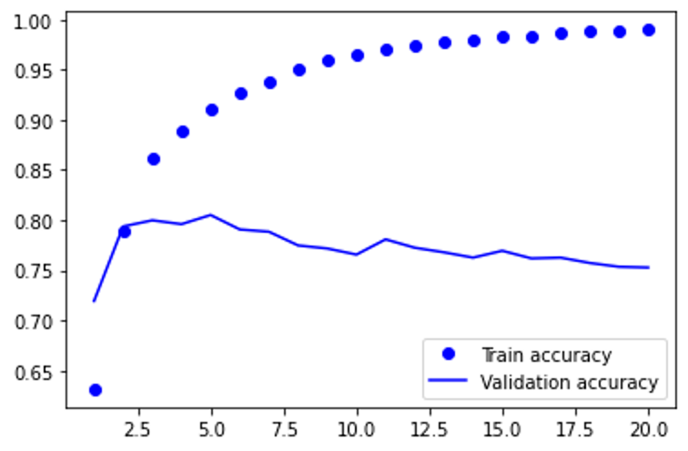

Results in the test set: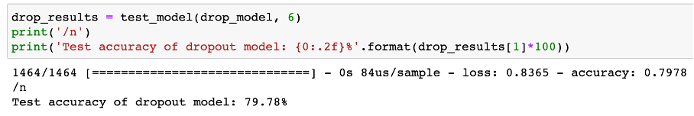

**2.2 Training data test data set split of original hotness dataset**

First transform the data, turn the day into a number, and then visualize the hotness data from nasdaq after the conversion to find the law. First transform the data, turn the day into a number, and then visualize the effective data after the conversion to find the law.

We have to choose an algorithm to predict future visits, which is obviously supervised learning.

Before building our first model, we need to design an evaluation function to judge what kind of model is good. That is, the error function, which can be calculated like this,

def error(f, x,y):

return sp.sum( (f(x) - y)**2 )

and evaluated by the square of the difference between the predicted value of the model and the true value (the training sample has been provided)

Linear regression

**Linear regression**：It is easy to know that this is actually a fitting problem. Fit these data to the best model (ie a function, and then use this function to predict new data). Starting from the simplest case, we first go to a straight line to fit the data. SciPy provides the function polyfit(), as long as the data x and y and the order of the polynomial are given (a straight line is a function of 1st order), it can find the function of the model so that the previously defined error function is minimized (only the smallest error is the surface The best model). Type in: fp1,residuals,rank,sv,rcond=sp.polyfit(x,y,1,full=True)

**Polynomial regression**：A straight line is a first-order function, obviously not optimized enough, and then we start to consider the second-order curve, the third-order

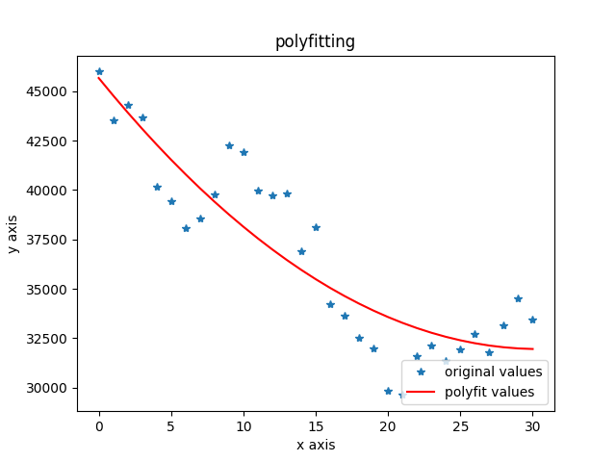

**2.3 Training data test data set split of original hotness dataset with consideration of sentiment of tweets of whole twitter and MVP account of #Place**

Building a time series forecasting model

Index selection: The first is the choice of indicators. For sentiment indicators, this article chooses a bullish index. Calculate the time series data of sentiment indicators in units of days. As shown in the following formula

We first do Correlation analysis of hotness and our indicators we choose.

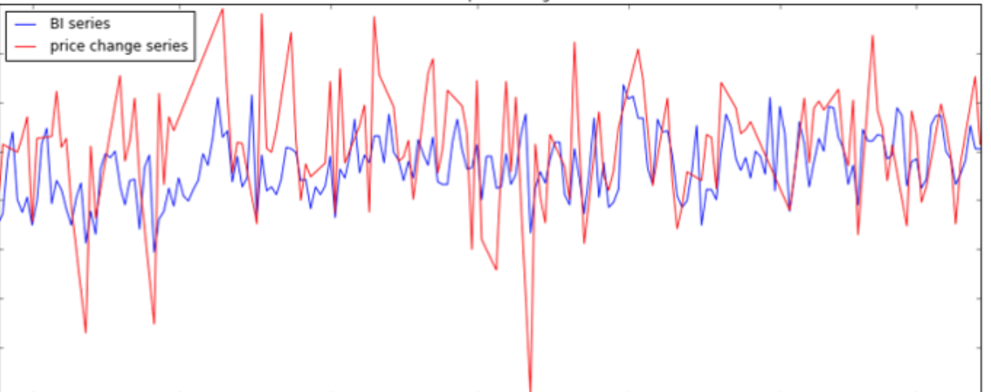

The ARIMA model consists of 3 parts, namely autoregressive (AR), traction (I), and moving * average (MA). They are:

ARIMA(p, d, q) consists of three parts:

AR(p): AR is the abbreviation of autoregressive, which means autoregressive model, meaning that the value of the current time point is equal to the regression of the value of several time points in the past-because it does not depend on other explanatory variables, only depends on the past The historical value is called autoregressive; if it relies on the last p historical values ​​in the past, the order is called p, and it is recorded as the AR(p) model.

I(d): I is the abbreviation of integrated, which means that the model differentiates the time series; because time series analysis requires stationarity, unstationary series need to be transformed into stationary series by certain means, and the generally used means is difference; d Represents the order of difference, the value at time t minus the value at time t-1, the new time series is called the first-order difference sequence; the first-order difference sequence of the first-order difference sequence is called the second-order difference sequence, and so on ; In addition, there is a special difference is the seasonal difference S, that is, some time series reflect a certain period T, let the value at time t minus the value at time tT to get the seasonal difference series.

MA(q): MA is the abbreviation of moving average, which means moving average model, meaning that the value of the current time point is equal to the regression of the forecast error at several time points in the past; forecast error = model predicted value-true value; if the sequence depends on the past The most recent q historical prediction error values, called the order q, are recorded as the MA(q) model.

I(d) is well understood, and the non-stationary sequence difference is obtained as a stationary sequence, and the table is omitted. Assume that our current time series is already stationary.

I(d) is well understood, and the non-stationary sequence difference is obtained as a stationary sequence, and the table is omitted. Assume that our current time series is already stationary.

The AR(p) model is well understood. Generally speaking, time series variables have time series correlation. For example, the speed of a road, when the time interval is small enough, if the speed at the previous point in time is slow, the next point in time is often very slow. This inherent correlation allows us to predict the value of the next few time points based on the observations of the most recent time points.

Predicted value of Y = a constant and/or a weighted sum of one or more recent values of Y and/or a weighted sum of one or more recent values of the errors. If the predictors consist only of lagged values of Y, it is a pure autoregressive (“self-regressed”) model, which is just a special case of a regression model and which could be fitted with standard regression software. For example, a first-order autoregressive (“AR(1)”) model for Y is a simple regression model in which the independent variable is just Y lagged by one period (LAG(Y,1) in or Y_LAG1 in RegressIt). If some of the predictors are lags of the errors, an ARIMA model it is NOT a linear regression model, because there is no way to specify “last period’s error” as an independent variable: the errors must be computed on a period-to-period basis when the model is fitted to the data.

AR stands for Auto Regression,

I mean a single integral order (Integration), the time series must be *stable in order to establish a stable model. After being transformed into a stable sequence, the following orders are single integers;

MA stands for Moving Average

In the ARIMA model, denote ARIMA(p, d, q), where p is the mean number of autoregressive terms; q is the number of steps to make *, and d is the number of steps to make * stable ordinal. The key step, the data predicted by the IMA model must be stable * stable), stable, it is impossible to capture AR mode data

1. **Index selection**

**The first is the choice of indicators. As shown in the following formula:**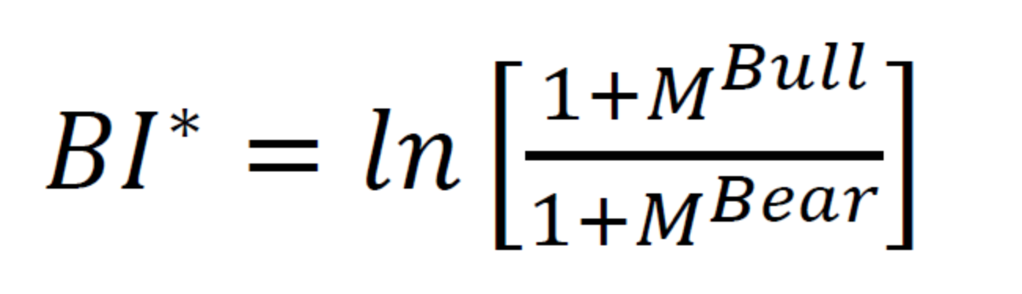

**my_index =ln( frac{m+M^{up}}/{m+M^{down}})**

**Where m we use math.e*base*100 , the base is empirical value we get from trial.**

**Get the daily unit hotness and #place hotness as time series data.**

**Where**

**up = the weight we assign * the amount of optimism analyzed by the twitter tag grab data set of the day + the weight we assign a key person and a small circle of key people * the corresponding amount of optimism**

**down = the weight we assign * the number of pessimistic sentiments analyzed by the Twitter tag grabbing data set of the day + the weight we assigned to a key person and a small circle of key people * the corresponding number of pessimistic sentiments**

**2)parameters selection**

**ARMA(p,q) has two parameters, p and q. According to the tailing feature of the autocorrelation graph, q=1, and p=2 according to the tailing feature of the partial autocorrelation graph. Further use the AIC criterion for parameter selection. The smaller the AIC, the better the model. Using the AIC criterion also obtains q=1, p=2**

**The chart below provides a brief guide on how to read the autocorrelation and partial autocorrelation graphs to select the proper terms. The big issue as with all models is that you don’t want to overfit your model to the data by using too many terms.**

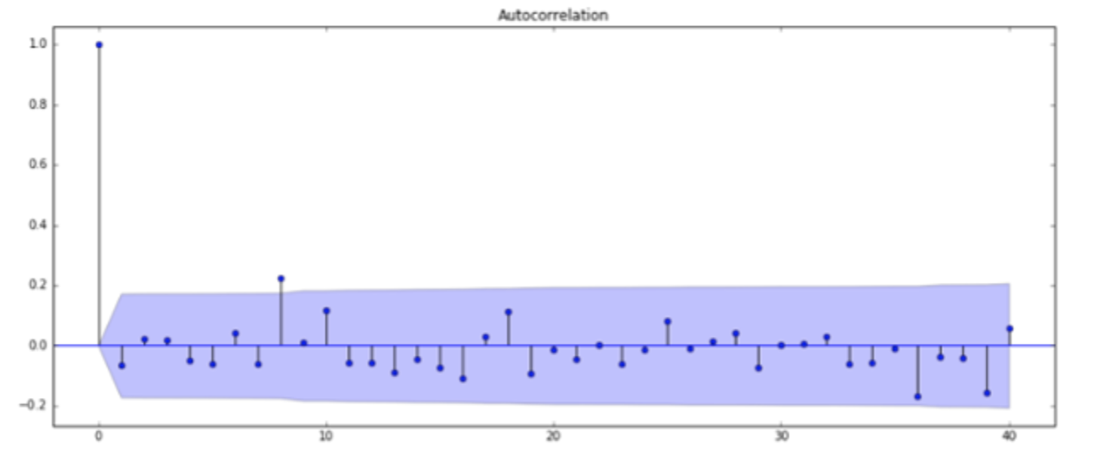

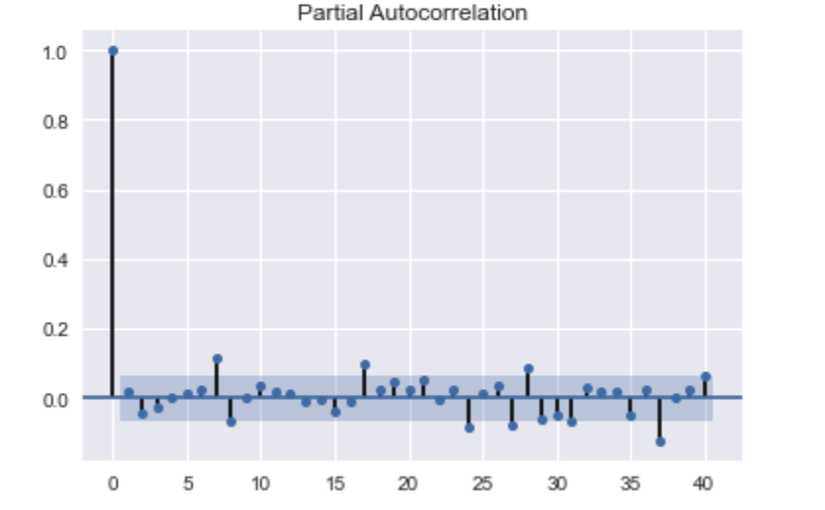

**3**）**why is improved hotness predict forecast**

**Exogenous variables refer to variables that are affected by external factors in the economic mechanism and can affect internal variables. The stock review sentiment index can be regarded as a comprehensive reflection of many exogenous variables, reflecting the macroeconomic, #place-related open source organizations or blockchain community fundamental information, policies, major events and many other external factors of #place hotness changes. We are not sure what the specific factors are, but we believe it is reflected in the hotness index. Therefore, the addition of exogenous variable model considerations improves the accuracy of hotness forecasts.**

**4) predict hotness use Arima to hotness, help adjust curve fitting**

**Fit Auto Arima: Fit the model on the univariate series**

**Adjust curve fitting of simple use the new Y( adjust by our Arima model)**

**Predict values on validation set: Make predictions on the validation set**

For the **#Place** indicator, select the closing hotness and the fluctuation range for research. Get the closing hotness and the time series data of the rise and fall in units of days

we have also achieved a pure distance planning, without considering the weather factor, social network popularity and emotional memory, and the planning is not very simple. This kind of planning is impossible to consider recent regional related events (for example, roads have been dug or large-scale events are held in the park), and there is no way to plan ahead.

As compare , we use an advance way to plan routines : we use external model（Arima like), and then integrate the latitude and longitude distances, and at the same time integrate the popularity of social networks, the polarity and quantity of positive emotions into a multi-dimensional matrix for consideration and calculations to generate a comprehensive travel plan

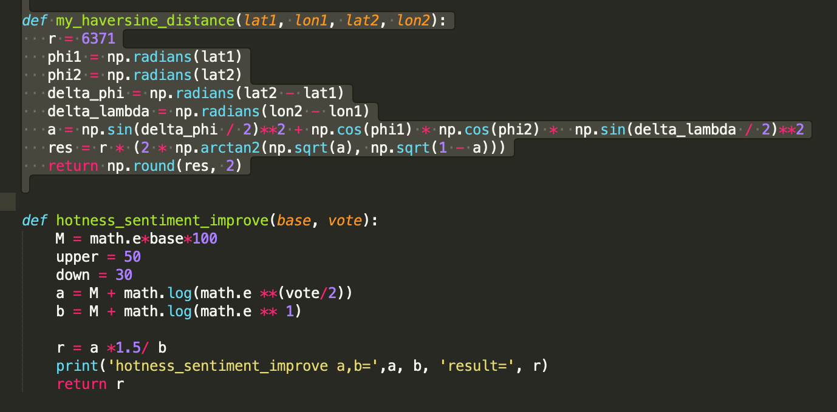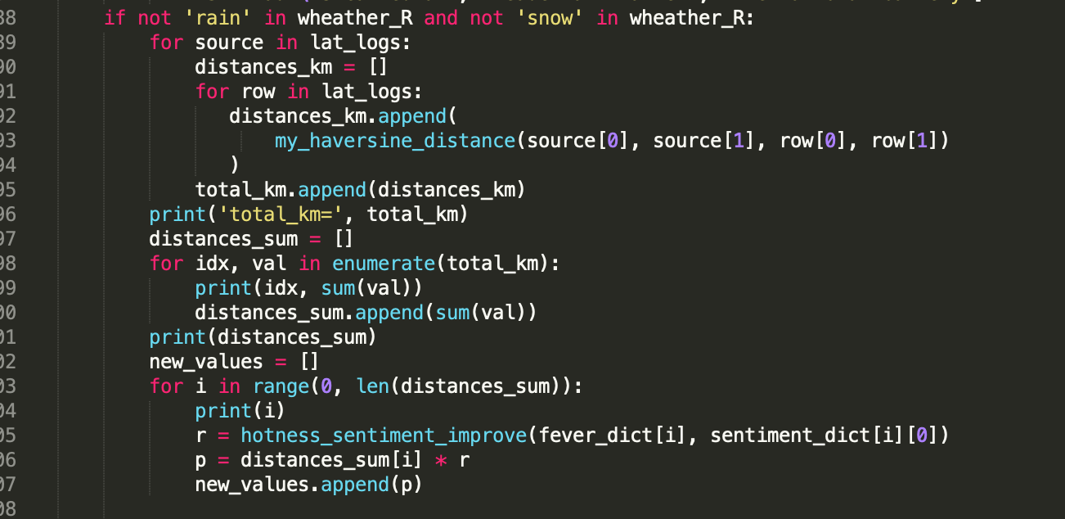

Conclusion

About the sentiment model:

As we have seen above, the model with the dropout layer performs best on the test data. However, this is the same as the result achieved with LogisticRegression and Countvectorizer in our previous kernel. But there, the transformation of the input data is different from here.

Deep learning machine learning models are used in sentiment analysis because they provide more information than text. Deep learning models map input to some feature spaces, and different forms of input from multimodal data can also be projected into some joint latent spaces or representations by these models. Therefore, the trend of using deep learning models to process multi-modal data continues to grow.

About hotness predict:

First, build a deep learning model for sentiment analysis classification to realize rapid judgment of the sentiment tendency of tourist keyword (place/good or bad for tourist) comments.

Second, comprehensive monitoring of keyword dynamic information on tweets, as well as keyword-related tweets information

Third, the network propagation structure of big v is analyzed, and the main nodes of big v interaction are also considered in the final prediction algorithm.

(For the sentiment index/hot index/big v index, we designed the bullish/bearish index ourselves.

Travel behavior is an individualized choice, and the travel psychology is subjective, and the travel distribution model must reflect the travel characteristics and scale of travelers, not only qualitatively but also quantitatively. Psychology cannot be quantified, but the factors that affect psychology can be quantified. Therefore, identifying the core factors that affect travel psychology and quantifying the relationship between it and travel behavior has become a breakthrough in quantifying travel psychology. I think we are on the right way.

Reflection/Learning

This research proposes a time-space travel planning algorithm, which can provide tourists with the best and personalized travel planning. In the selection of scenic spots and the analysis of the optimal scenic spot sequence, it considers external factors such as social networks and emotional tendencies, weather and Google trend.

It has some novel features and can complete functions that cannot be completed by existing systems and provide users with high-quality services. . The algorithm proposed in this paper enables users to visit the most worthwhile scenic spots within the limits of travel time. The framework structure of the optimal spatiotemporal sequence query proposed in this study is universal, and the proposed technology

The technical algorithm can also be applied to recommendations in other fields, such as watching different art exhibitions.

References

[1] Rumelhart D E, Hinton G E, Williams R J. Learning representations by back-propagating errors.[J]. 1986, 323(6088):399-421.

[2] Cover T M, Hart P E. Nearest neighbor pattern classification. IEEE Trans Inf Theory IT-13(1):21-27[J]. IEEE Transactions on Information Theory, 1967, 13(1):21-27.

[3] Daral N. Histograms of Oriented Gradients for Human Detection[J]. Proc. of CVPR, 2005, 2005.

[3.1] Histograms of Oriented Gradients for Human Detection. Dalai,N,B.Triggs. Computer Vision and Pattern Recognition, 2005.CVPR 2005.IEEE Computer Society Conference on . 2005

[4] Kazemi V, Sullivan J. One Millisecond Face Alignment with an Ensemble of Regression Trees[C] Computer Vision and Pattern Recognition. IEEE, 2014:1867-1874.

[5] David J. Hand and Robert J. Till（ 2001）. A Simple Generalization of the Area Under the ROC Curve for Multiple Class Classification Problems . Machine Learning , 45(2), 171 – 186 .

周志华，机器学习，清华大学出版社，2016

李航，统计学习方法，清华大学出版社，2012

Scikit-learn，https://scikit-learn.org/stable/index.html

Qcon 2017 feature engineering by Gabriel Moreira

Thomas M.Cover, JoyA. Thomas. Elementsof InformationTheory. 2006

Christopher M.Bishop. Pattern Recognition and Machine Learning. Springer-Verlag. 2006

新增：

[1]    Adam, Klaus, Albert Marcet, and Juan Pablo Nicolini. "Stock market volatility and learning." The Journal of finance 71.1 (2016): 33-82.

[2]    O'Shea, Keiron, and Ryan Nash. "An introduction to convolutional neural networks." arXiv preprint arXiv:1511.08458 (2015).

[3]    Medsker, Larry R., and L. C. Jain. "Recurrent neural networks." Design and Applications 5 (2001): 64-67.

[4]    Noble, William S. "What is a support vector machine?." Nature biotechnology 24.12 (2006): 1565-1567.

[5]    Hecht-Nielsen, Robert. "Theory of the backpropagation neural network." Neural networks for perception. Academic Press, 1992. 65-93.

[6]    Yu, Yong, et al. "A review of recurrent neural networks: LSTM cells and network architectures." Neural computation 31.7 (2019): 1235-1270.

[7]    Huang, Zhiheng, Wei Xu, and Kai Yu. "Bidirectional LSTM-CRF models for sequence tagging." arXiv preprint arXiv:1508.01991 (2015).

[8]    “Yahoo finance,” accessed: 2020-03-12. [Online]. Available: https:

//finance.yahoo.com/quote/GOOG/history?p=GOOG.

Agarap, Abien Fred. "Deep learning using rectified linear units (relu)." arXiv preprint arXiv:1803.08375 (2018).